Deploying Highly Available ETCD Cluster on Ubuntu 20.04 for Kubernetes Cluster

1. Create 3 servers in different availability zone using t2. medium.

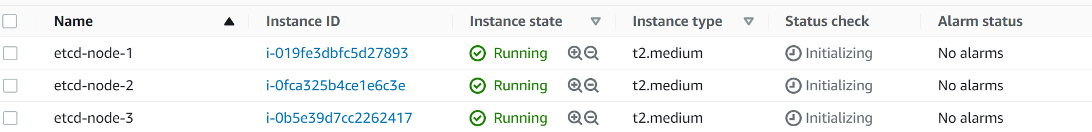

1. Update the hostname as shown below and reboot.

nano /etc/hostname

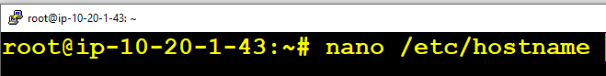

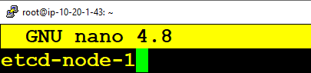

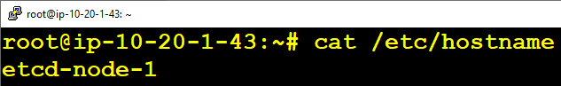

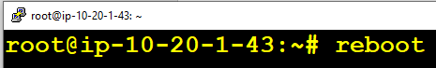

1. Follow the same steps on the other 2 nodes. As you can see all nodes are renamed.

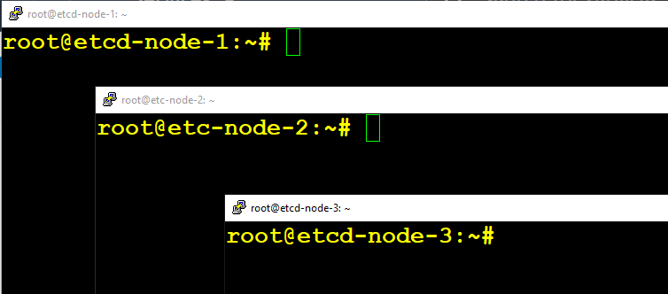

1. Updates the /etc/hosts so that all 3 nodes reach other over the name.

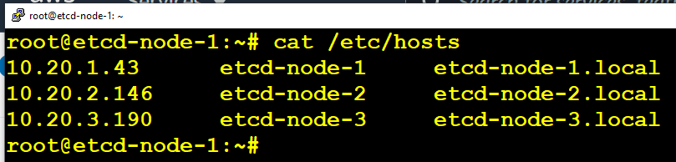

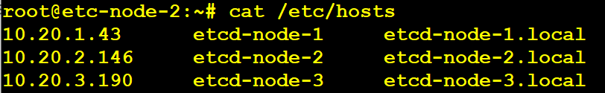

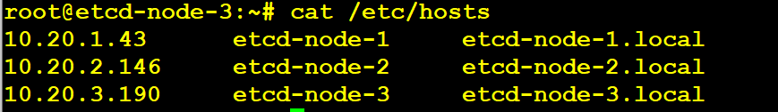

1. Download and copy etcd and etcdctl binaries to all servers in /usr/local/bin location.

Download etcd latest version from <https://github.com/etcd-io/etcd/releases>

------------------------------------------------------------------------------------------------

ETCD_VER=v3.5.1

GOOGLE_URL=https://storage.googleapis.com/etcd

GITHUB_URL=https://github.com/etcd-io/etcd/releases/download

DOWNLOAD_URL=${GOOGLE_URL}

curl -L ${DOWNLOAD_URL}/${ETCD_VER}/etcd-${ETCD_VER}-linux-amd64.tar.gz -o /tmp/etcd-${ETCD_VER}-linux-amd64.tar.gz

cd /tmp && ls -al

tar xzvf /tmp/etcd-${ETCD_VER}-linux-amd64.tar.gz

mv /tmp/etcd-v3.5.1-linux-amd64/etcd* /usr/local/bin/

rm -f /tmp/etcd-${ETCD_VER}-linux-amd64.tar.gz

rm -rf etcd-v3.5.1-linux-amd64

ls -al /usr/local/bin/

------------------------------------------------------------------------------------------------

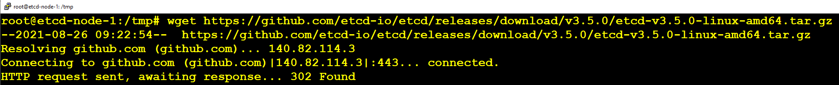

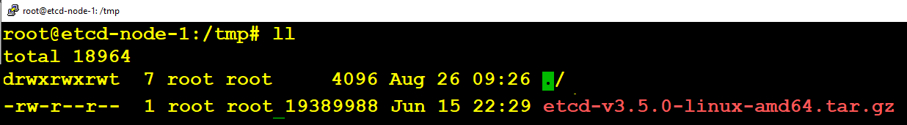

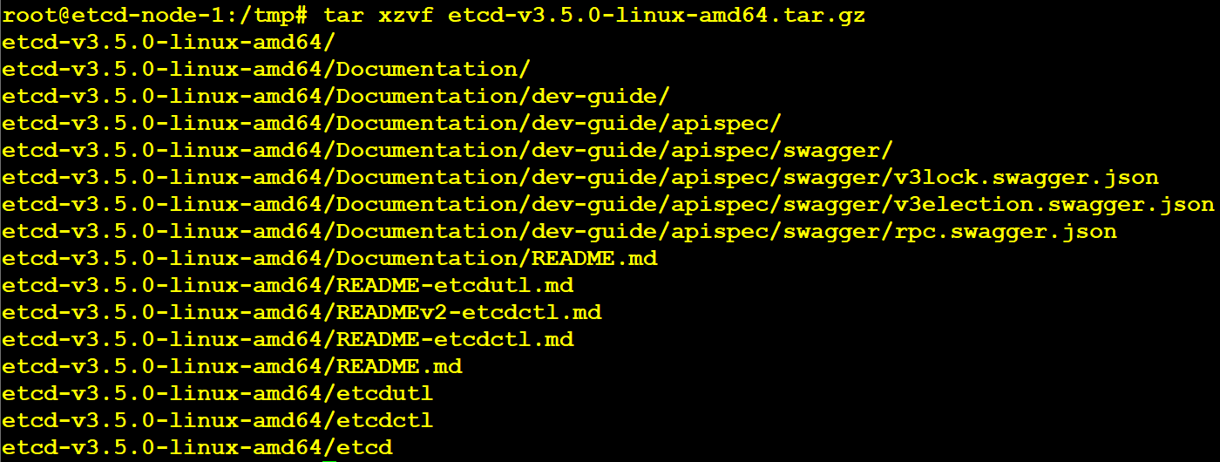

1. Moving etcd and etcdctl to /usr/local/bin



1. Check etcd and etcdctl version

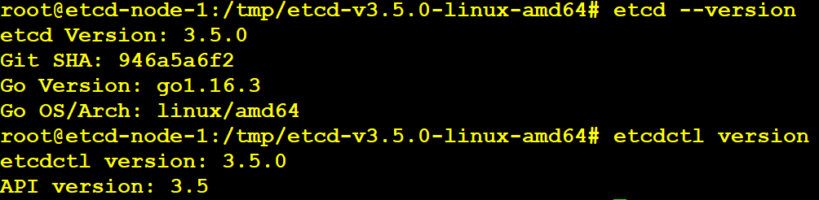

1. Perform steps 5,6,7 in etcd-node-2 & etcd-node-3

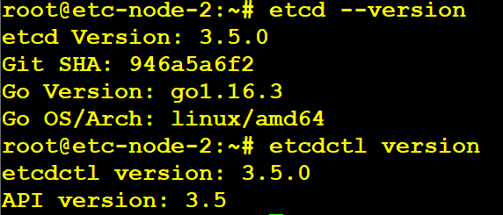

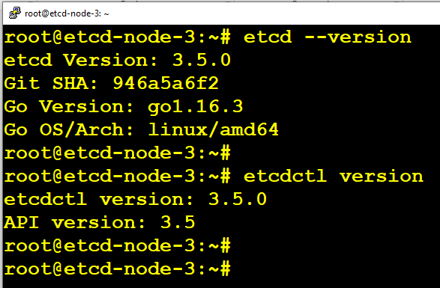

Generating certificates for ETCD Secure connectivity:

Installing Cloudflare SSL generation tool:

apt update && apt install -y golang-cfssl

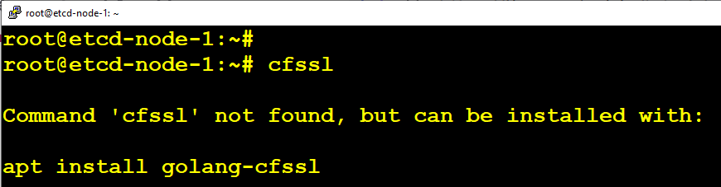



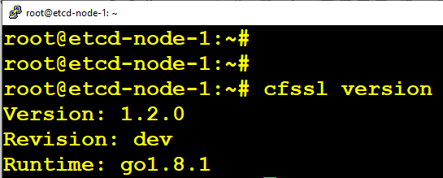

Generating Certificates for ETCD and Nodes:

mkdir certs && cd certs

echo '{"CN":"CA","key":{"algo":"rsa","size":2048}}' | cfssl gencert -initca - | cfssljson -bare ca -

echo '{"signing":{"default":{"expiry":"43800h","usages":["signing","key encipherment","server auth","client auth"]}}}' >> ca-config.json

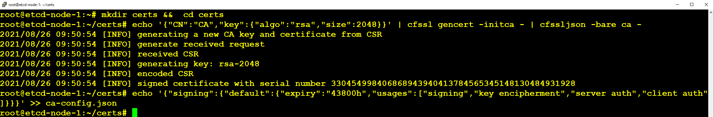

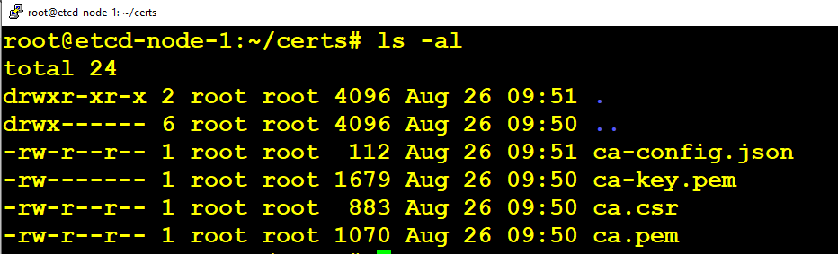

Change NAME and ADDRESS in the below commands:

export NAME=etcd-node-1

export ADDRESS=10.20.1.43,$NAME

echo '{"CN":"'$NAME'","hosts":[""],"key":{"algo":"rsa","size":2048}}' | cfssl gencert -config=ca-config.json -ca=ca.pem -ca-key=ca-key.pem -hostname="$ADDRESS" - | cfssljson -bare $NAME

export NAME=etcd-node-2

export ADDRESS=10.20.2.146,$NAME

echo '{"CN":"'$NAME'","hosts":[""],"key":{"algo":"rsa","size":2048}}' | cfssl gencert -config=ca-config.json -ca=ca.pem -ca-key=ca-key.pem -hostname="$ADDRESS" - | cfssljson -bare $NAME

export NAME=etcd-node-3

export ADDRESS=10.20.3.190,$NAME

echo '{"CN":"'$NAME'","hosts":[""],"key":{"algo":"rsa","size":2048}}' | cfssl gencert -config=ca-config.json -ca=ca.pem -ca-key=ca-key.pem -hostname="$ADDRESS" - | cfssljson -bare $NAME

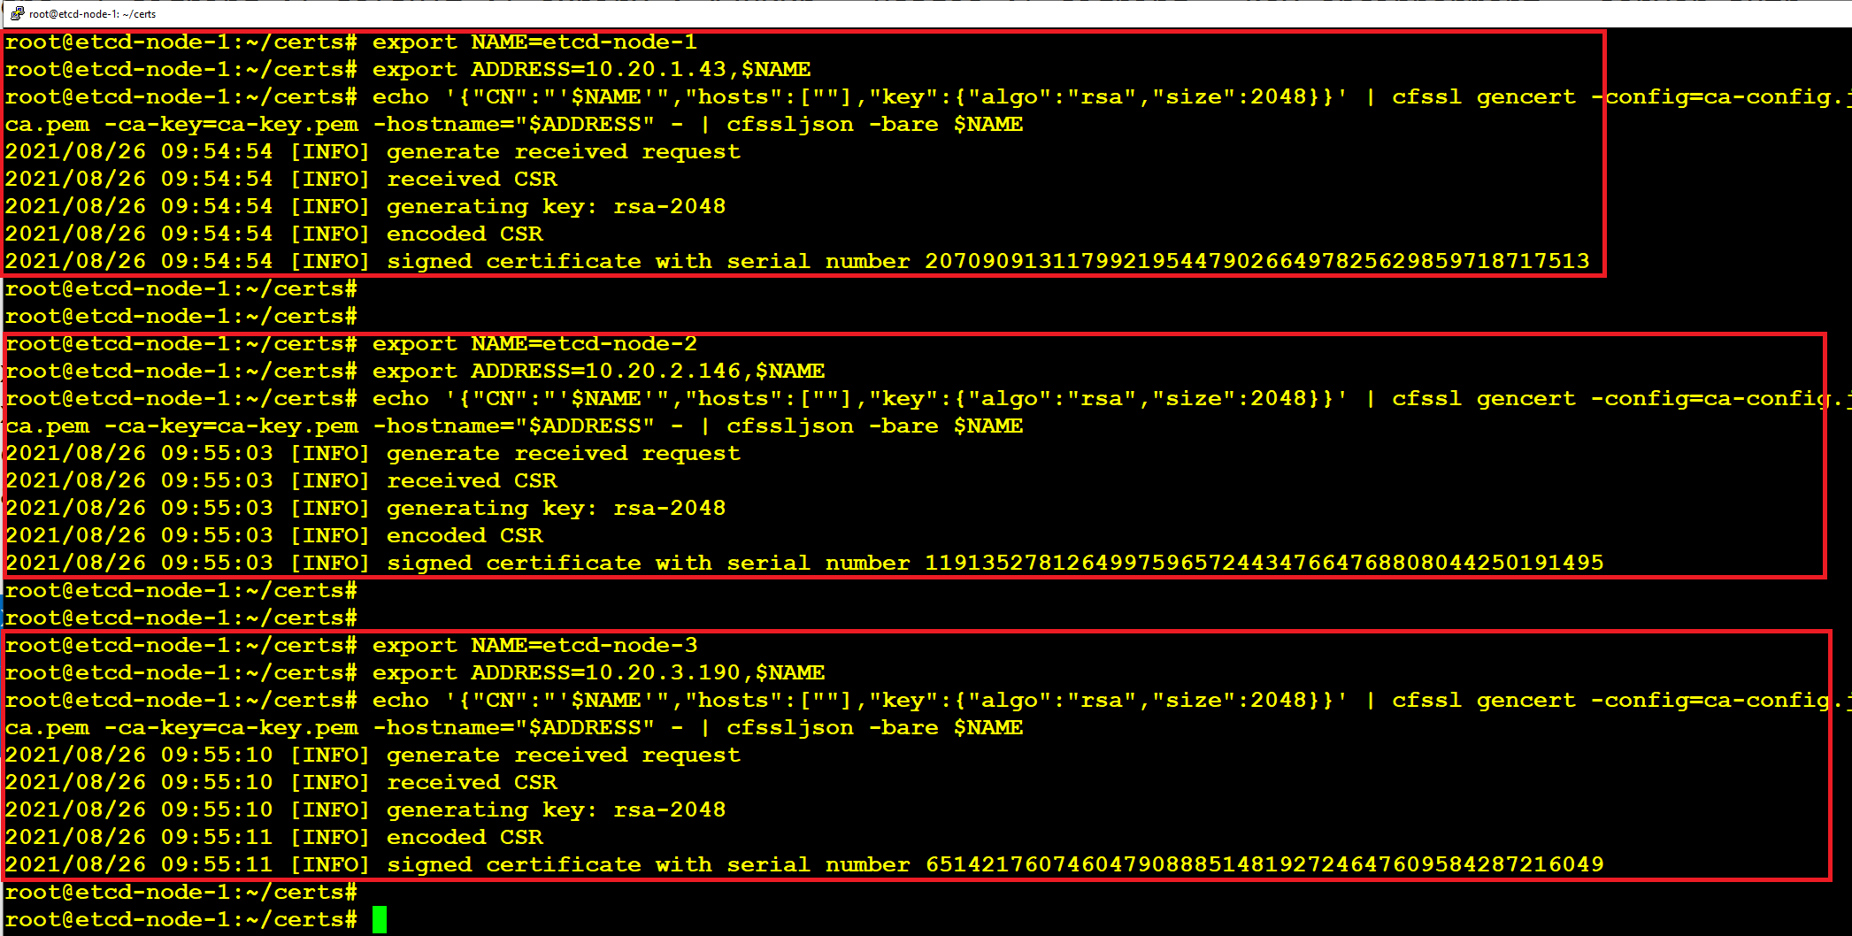

Following are the list of certificates created using CFSSL

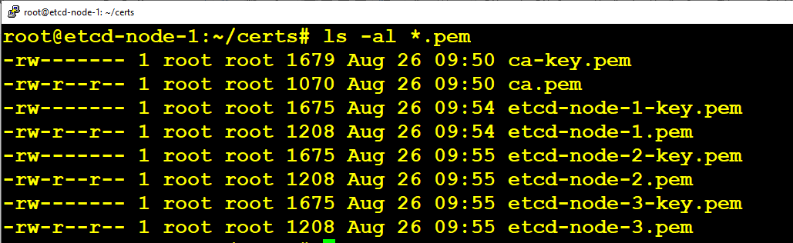

Create etcd directory under /etc folder. Copy certificates as shown below in to the nodes.

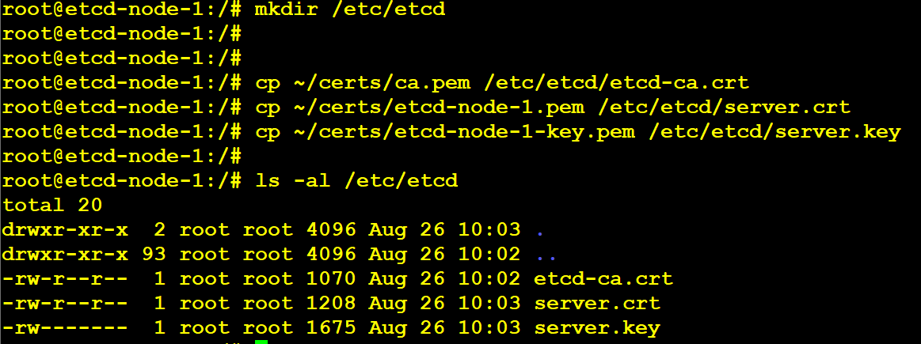

Copy the ca.pem and node.pem and node.key using SCP to other nodes.

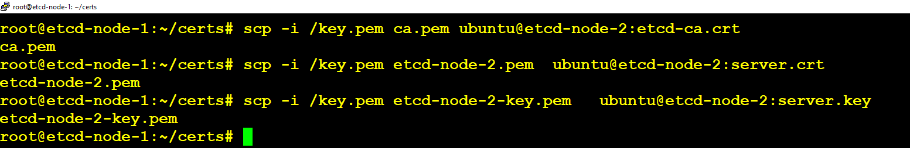

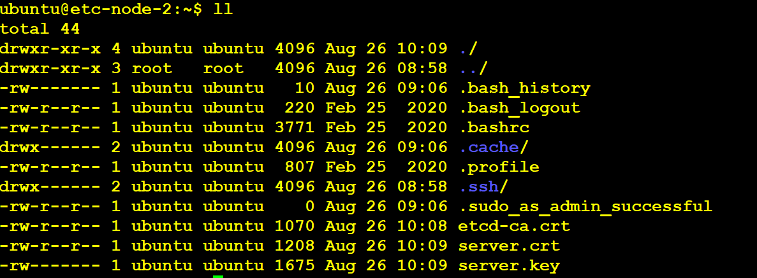

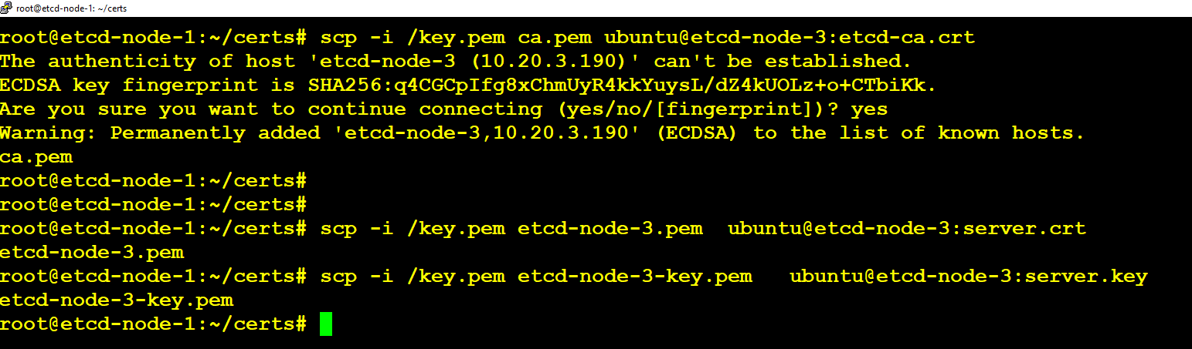

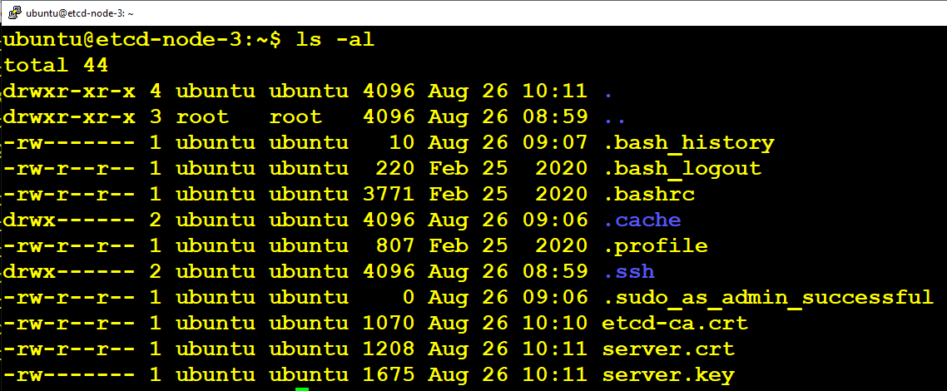

We need to move the certificates to /etc/etcd in etcd-node-2 & etcd-node-3

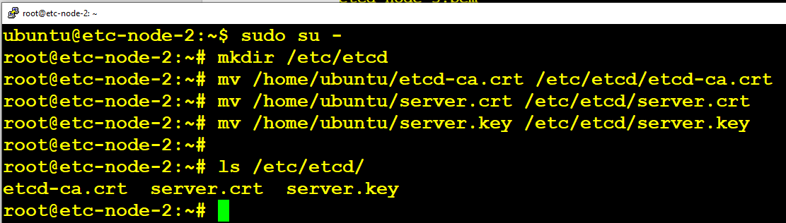

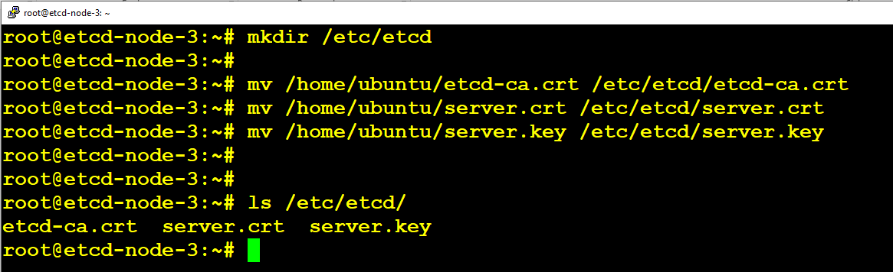

Need to create etcd.conf files for all the nodes inside /etc/etcd folder as shown below. Repalce name and IP as per your environment.

ETCD_NAME=etcd-node-1

ETCD_LISTEN_PEER_URLS="https://10.20.1.43:2380"

ETCD_LISTEN_CLIENT_URLS="https://10.20.1.43:2379"

ETCD_INITIAL_CLUSTER_TOKEN="etcd-cluster"

ETCD_INITIAL_CLUSTER="etcd-node-1=https://10.20.1.43:2380,etcd-node-2=https://10.20.2.146:2380,etcd-node-3=https://10.20.3.190:2380"

ETCD_INITIAL_ADVERTISE_PEER_URLS="https://10.20.1.43:2380"

ETCD_ADVERTISE_CLIENT_URLS="https://10.20.1.43:2379"

ETCD_TRUSTED_CA_FILE="/etc/etcd/etcd-ca.crt"

ETCD_CERT_FILE="/etc/etcd/server.crt"

ETCD_KEY_FILE="/etc/etcd/server.key"

ETCD_PEER_CLIENT_CERT_AUTH=true

ETCD_PEER_TRUSTED_CA_FILE="/etc/etcd/etcd-ca.crt"

ETCD_PEER_KEY_FILE="/etc/etcd/server.key"

ETCD_PEER_CERT_FILE="/etc/etcd/server.crt"

ETCD_DATA_DIR="/var/lib/etcd"

etcd-node-1 Configuration:

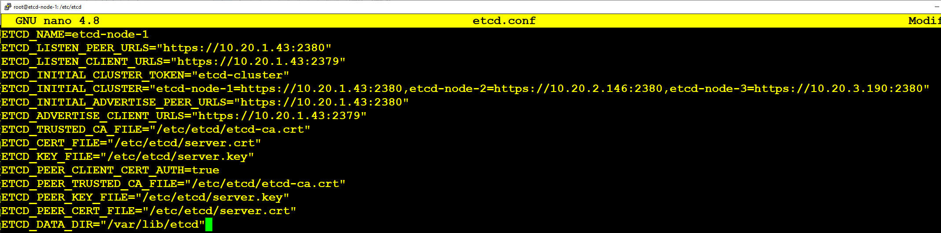

etcd-node-2 Configuration:

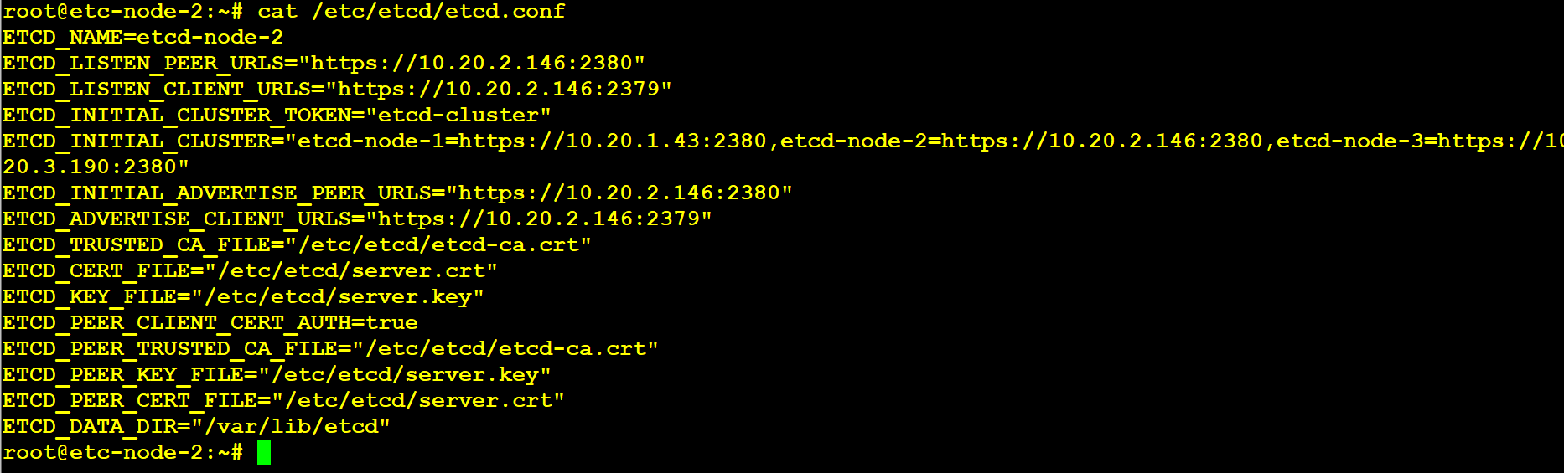

etcd-node-3 Configuration:

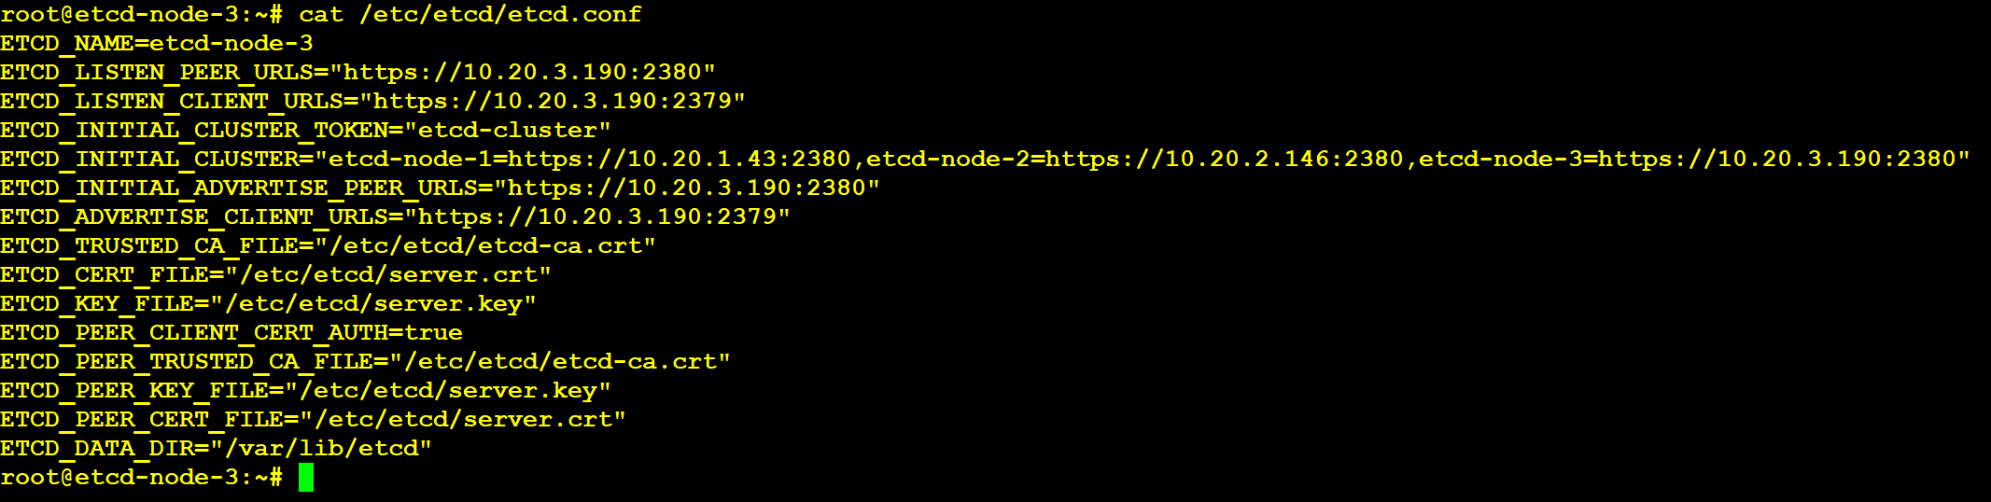

nano /lib/systemd/system/etcd.service

[Unit]

Description=etcd key-value store

Documentation=https://github.com/etcd-io/etcd

After=network.target

[Service]

Type=notify

EnvironmentFile=/etc/etcd/etcd.conf

ExecStart=/usr/local/bin/etcd

Restart=always

RestartSec=10s

LimitNOFILE=40000

[Install]

WantedBy=multi-user.target

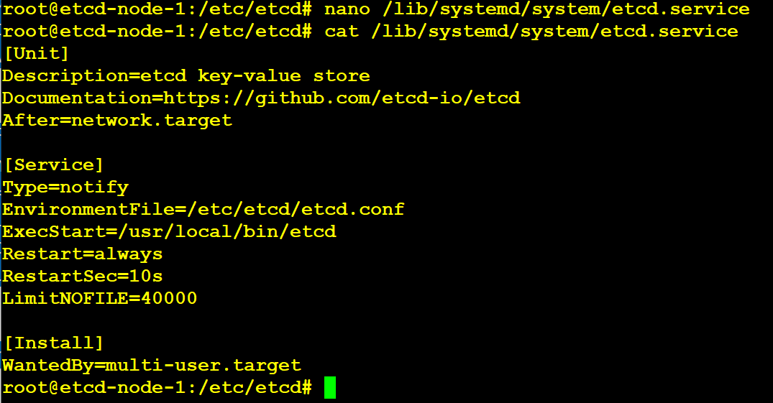

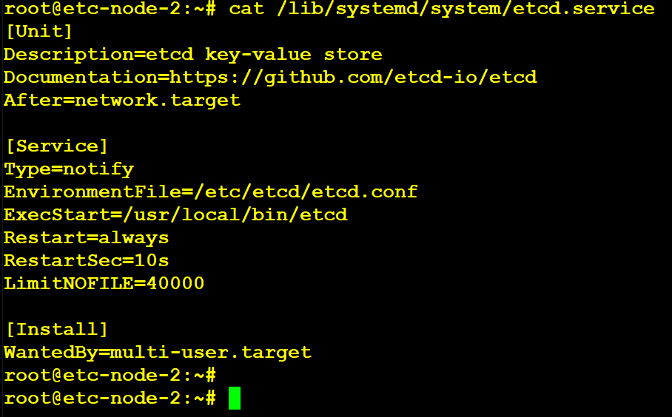

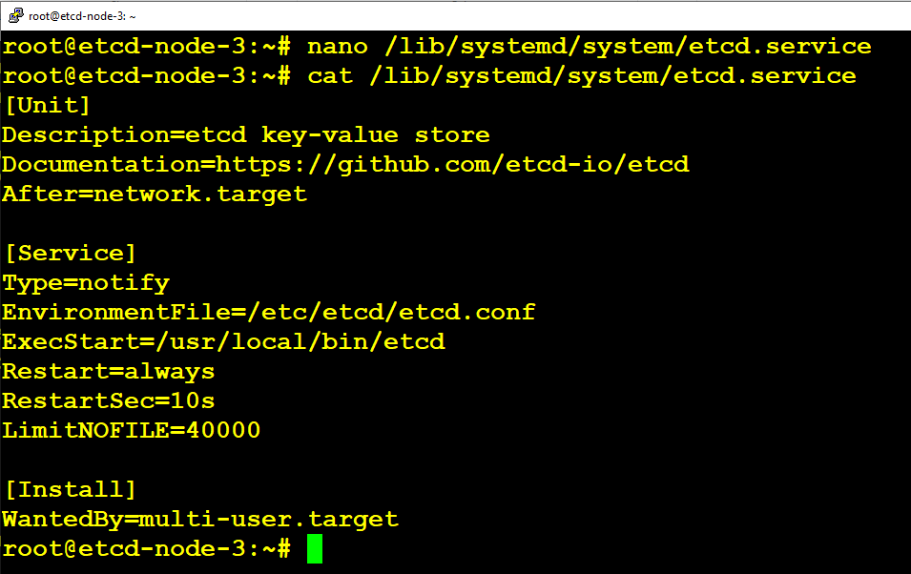

We are now ready to start the service. Run the below command on each node to start the etcd cluster.

sudo systemctl daemon-reload

sudo systemctl enable etcd

sudo systemctl start etcd

sudo systemctl status etcd

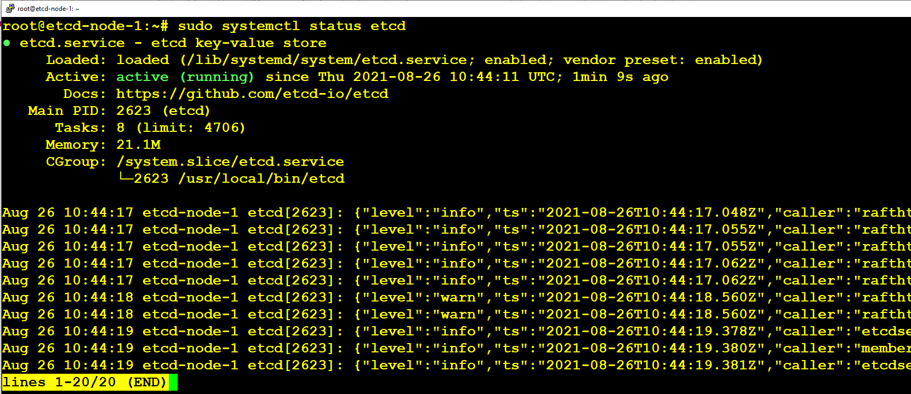

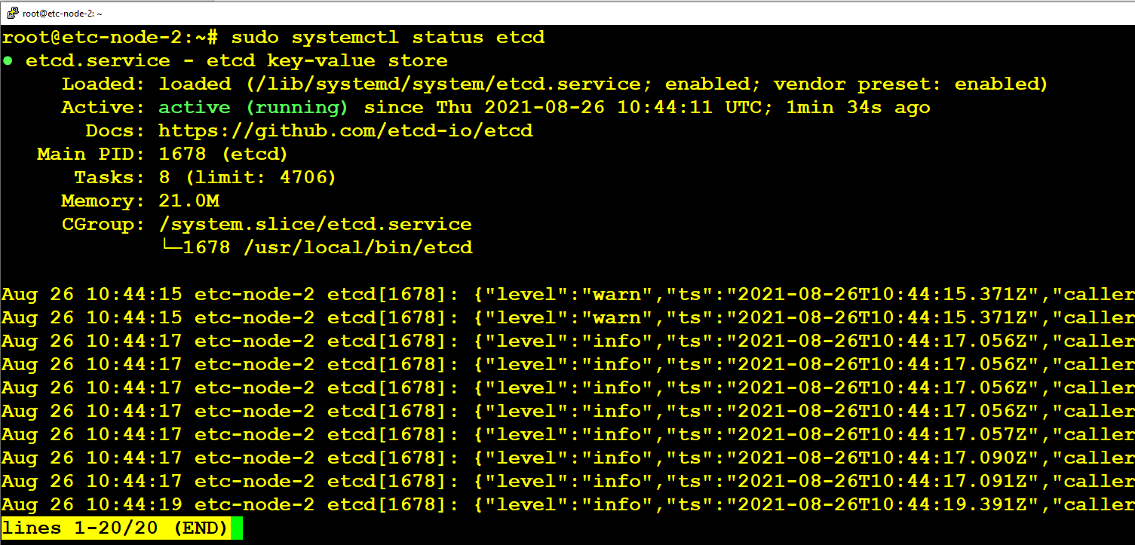

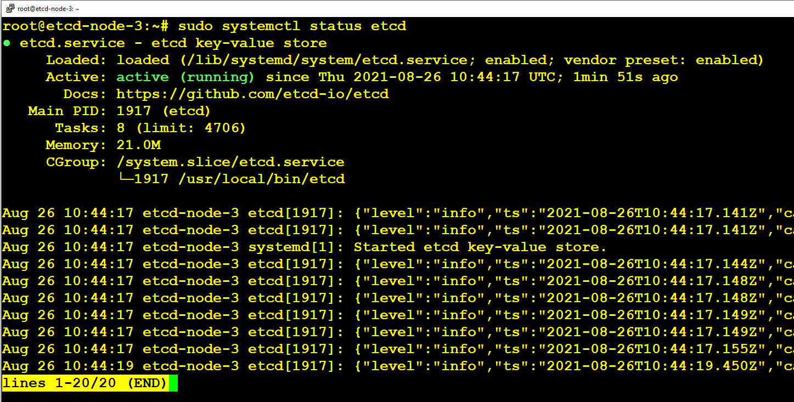

etcdctl --endpoints https://10.20.1.43:2379 --cert /etc/etcd/server.crt --cacert /etc/etcd/etcd-ca.crt --key /etc/etcd/server.key put foo bar

etcdctl --endpoints https://10.20.1.43:2379 --cert /etc/etcd/server.crt --cacert /etc/etcd/etcd-ca.crt --key /etc/etcd/server.key get foo

etcdctl --endpoints https://10.20.2.146:2379 --cert /etc/etcd/server.crt --cacert /etc/etcd/etcd-ca.crt --key /etc/etcd/server.key get foo

etcdctl --endpoints https://10.20.3.190:2379 --cert /etc/etcd/server.crt --cacert /etc/etcd/etcd-ca.crt --key /etc/etcd/server.key get foo

etcdctl --endpoints https://10.20.1.43:2379 --cert /etc/etcd/server.crt --cacert /etc/etcd/etcd-ca.crt --key /etc/etcd/server.key get Chiru

etcdctl --endpoints https://10.20.2.146:2379 --cert /etc/etcd/server.crt --cacert /etc/etcd/etcd-ca.crt --key /etc/etcd/server.key get Nag

etcdctl --endpoints https://10.20.3.190:2379 --cert /etc/etcd/server.crt --cacert /etc/etcd/etcd-ca.crt --key /etc/etcd/server.key get AArjun

Chiranjeevi => Megastar

Nagarjura => YuvaSamrat

Venkatesh => Victory

NTR => YoungTiger

etcdctl --endpoints https://172.16.1.138:2379 --cert /etc/etcd/server.crt --cacert /etc/etcd/etcd-ca.crt --key /etc/etcd/server.key put Chiranjeevi Megastar

etcdctl --endpoints https://172.16.1.225:2379 --cert /etc/etcd/server.crt --cacert /etc/etcd/etcd-ca.crt --key /etc/etcd/server.key put Nagarjura YuvaSamrat

etcdctl --endpoints https://172.16.1.163:2379 --cert /etc/etcd/server.crt --cacert /etc/etcd/etcd-ca.crt --key /etc/etcd/server.key put Venkatesh Victory

etcdctl --endpoints https://172.16.1.138:2379 --cert /etc/etcd/server.crt --cacert /etc/etcd/etcd-ca.crt --key /etc/etcd/server.key get Chiranjeevi

etcdctl --endpoints https://172.16.1.225:2379 --cert /etc/etcd/server.crt --cacert /etc/etcd/etcd-ca.crt --key /etc/etcd/server.key get Nagarjura

etcdctl --endpoints https://172.16.1.163:2379 --cert /etc/etcd/server.crt --cacert /etc/etcd/etcd-ca.crt --key /etc/etcd/server.key get Venkatesh